Exposure to the herbicide 2,4-D increases virulence of a global amphibian pathogen

An Martel^{a*}, Ellen Blomme^{a*}, Elin Verbruggheª, Sofie Debruyckereª, Sarah Van Praetª, Manuel E. Ortiz-Santaliestra^{b}, Frank Pasmansª

ª Wildlife Health Ghent, Faculty of Veterinary Medicine, Ghent University, Salisburylaan 133, B-9820 Merelbeke, Belgium
^{b} Instituto de Investigación en Recursos Cinegéticos (IREC) CSIC-UCLM-JCCM. Ronda de Toledo 12, 13005 Ciudad Real, Spain
^{* shared contribution}

Highlights
- Exposure to an endemic Batrachochytrium dendrobatidis strain of the global panzootic lineage (BdGPL) results in a higher infection burden in frog metamorphs, but at a lower cost for the host compared to an exotic strain
- Short-term exposure of tadpoles to the herbicide 2,4-D results in dose dependent stunted growth until after metamorphosis
- Short-term exposure of tadpoles to 2,4-D brings virulence of the low-virulent BdGPL strain on par with that of the highly virulent strain

Graphical abstract

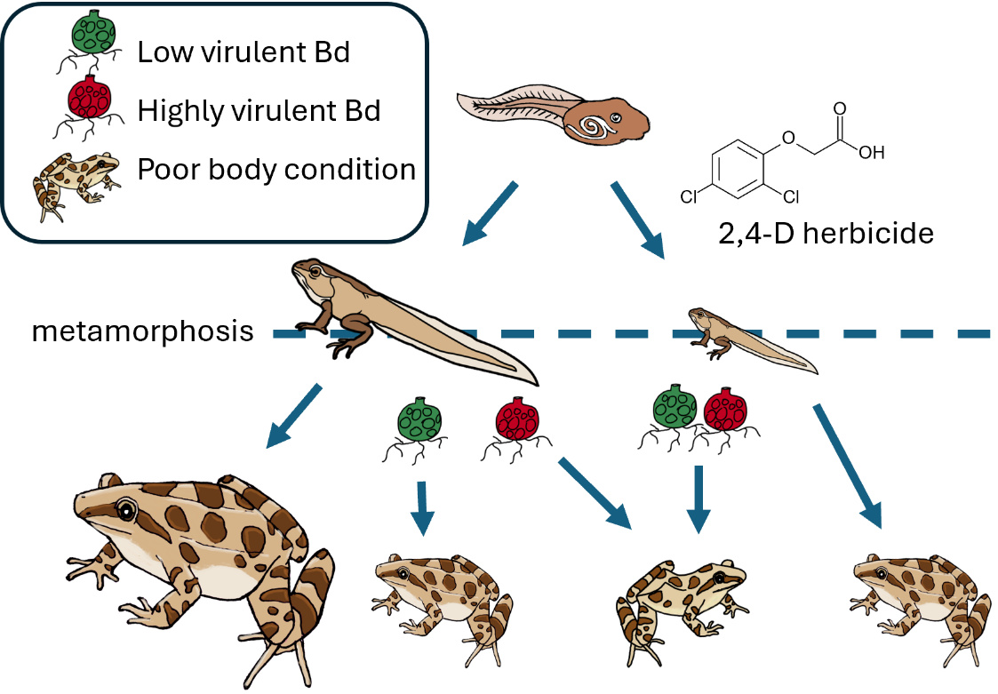
Abstract
Exposure to multiple environmental stressors threatens amphibian survival globally. While infections and pesticides are capable of driving declines, interactions may exacerbate their impact. Here, we study experimental exposure of painted frogs (Discoglossus pictus) to a commonly used herbicide (2,4-D) and/or to a presumedly highly (JEL423) or low (BdBE3) virulent strain of the global panzootic lineage of Batrachochytrium dendrobatidis (BdGPL), a pathogenic fungus involved in amphibian declines and extinctions. Inoculation of both tadpoles and metamorphs with JEL423 impaired growth and reduced body condition of metamorphs, while inoculation with BdBE3 resulted in higher level infections that only reduced metamorph growth when inoculated at the metamorph stage. A higher pathogen burden at a lower cost for the anuran host corroborates the hypothesis of low virulent endemic BdGPL strains (BdBE3) versus highly virulent exotic strains (JEL423). Exposure of tadpoles to 2,4-D shortly before metamorphosis reduced froglet size at metamorphosisin a dose-dependent manner. Co-exposure to both 2,4-D during the tadpole stage and the BdGPL strains resulted in significant loss of body condition in the low virulent BdBE3 inoculated frogs, bringing its negative impact on par with that observed after inoculation with the highly-virulent JEL423 strain. We demonstrate how the use of herbicides may exacerbate the impact of endemic infections in early life stage amphibians.

Keywords: pesticides – amphibians - chytridiomycosis – 2,4-Dichlorophenoxyacetic acid (2,4-D)

1. Introduction
Amphibian declines are a hallmark of the current, human-mediated sixth mass extinction event. Besides habitat loss and climate change, disease has been identified as a key driver of amphibian extinction (Luedtke et al., 2023; Scheele et al., 2019). The fungal skin disease chytridiomycosis has a global, amphibian class-wide impact and has been associated with the decline of at least 501 amphibian species and even extinction of at least 90 species over the past half-century. Chytridiomycosis has caused the greatest recorded loss of biodiversity attributable to a disease (Scheele et al., 2019). The vast majority of chytridiomycosis-driven declines have been associated with the hypervirulent and panzootic lineage of the fungus Batrachochytrium dendrobatidis (BdGPL) (Scheele et al., 2019). In Europe, the impact of BdGPL varies markedly, from regional population declines (Bosch et al., 2001; Bosch and Martínez-Solano, 2006; Clare et al., 2016) to coexistence with amphibian communities in the absence of population declines (Greener et al., 2020). While this can be partly attributed to pronounced differences in fungal strain virulence (Greener et al., 2020), environmental conditions, including pesticide exposure, may alter infection outcome by impairing pathogen viability or host defenses (Barbi et al., 2023; Chew et al., 2024; Gaietto et al., 2014; McMahon et al., 2013; Wise et al., 2014).
Agrochemical use is an important component of global agricultural systems, allowing for significant increases in crop yields and food production (Carvalho, 2017) but also posing a potential risk to terrestrial (Trapp et al., 2020), freshwater (Mirzaei et al., 2017) and marine ecosystems (Vanryckeghem et al., 2019). Indeed, pesticides and fertilizers are an important stressor for amphibians in agriculturally dominated systems (Baker et al., 2013). Due to its cost-effectiveness, the agricultural herbicide 2,4-Dichlorophenoxyacetic acid (2,4-D) is one of the most widely used pesticides in the world (Maggi et al., 2019). It is a systemic herbicide targeting broadleaf weeds in agriculture, pastures, forest management, houses and gardens. 2,4-D is a stable and persistent auxin-like substance that disturbs a large number of processes involved in plant growth and development, resulting in an overstimulation of growth and finally death of the plants (Song, 2014). It is not easily biodegradable in aquatic environments (Chingombe et al., 2006) and is frequently detected in water bodies as a free anion. Residues of the herbicide in aquatic systems can result from the deposition of spray drifts, run-off from treated fields, the “washout” in the vapor or droplets from the atmosphere during rainfall or from the direct application to control invasive aquatic weeds (Yorlano et al., 2022). In regions with porous soils or where irrigation is intensive, 2,4-D can leak through soil and reach groundwater, which may feed into ponds and lakes. In agricultural areas, concentration levels fluctuate due to environmental conditions, application rates, and agricultural practices and range from trace amounts to 74,5 micrograms per liter (Brovini et al., 2021; Le et al., 2023). Toxicity in non-target species is dose-dependent, but even at low concentrations, 2,4-D can have adverse effects on aquatic life, particularly amphibians (Freitas et al., 2019; Santos et al., 2024).
Understanding the complex interaction between pesticides and fungal virulence may contribute to designing disease mitigation strategies. We here study the impact of 2,4-D on infection and disease course with a presumedly high- and low-virulent BdGPL strain in painted frogs (Discoglossus pictus) in a series of four experiments (Figure 1) to answer three questions. Does inoculation of tadpoles or metamorphs to an endemic, supposedly low virulent BdGPL strain result in a different course of infection compared to inoculation to a supposedly highly virulent, exotic strain? Does short term exposure of tadpoles to 2,4-D result in a dose dependent impact on tadpole and metamorph development? Does short term exposure of tadpoles to 2,4-D alter the course of infection of both Bd strains in the frogs, either when inoculated during the tadpole stage or after metamorphosis?

2. Material and methods

A schematic overview of the experimental design is provided in Figure 1. Four experiments were conducted to quantify the effect of treatments on infection loads, clinical signs of disease, growth and body condition of painted frog (Discoglossus pictus) metamorphs. Treatments consisted of exposure to the herbicide 2,4-D and/or one of two BdGPL strains: the supposedly highly virulent, exotic BdJEL423 and the supposedly low virulent, endemic (in Europe) BdBE3. In experiment 1, painted frogs were either sham-inoculated or inoculated with one of both BdGPL strains shortly after metamorphosis. In experiment 2, tadpoles were sham-inoculated or inoculated with one of both strains at the age of 14 days, and subsequently exposed to different 2,4-D concentrations (0, 0.03 (low) or 0.3 (high) mg/l) shortly before metamorphosis. In experiments 3 and 4, tadpoles were exposed to different 2,4-D concentrations (0, 0.03 or 0.3 mg/l) shortly before metamorphosis and inoculated either with BdJEL423 (experiment 3) or BdBE3 (experiment 4) after metamorphosis.

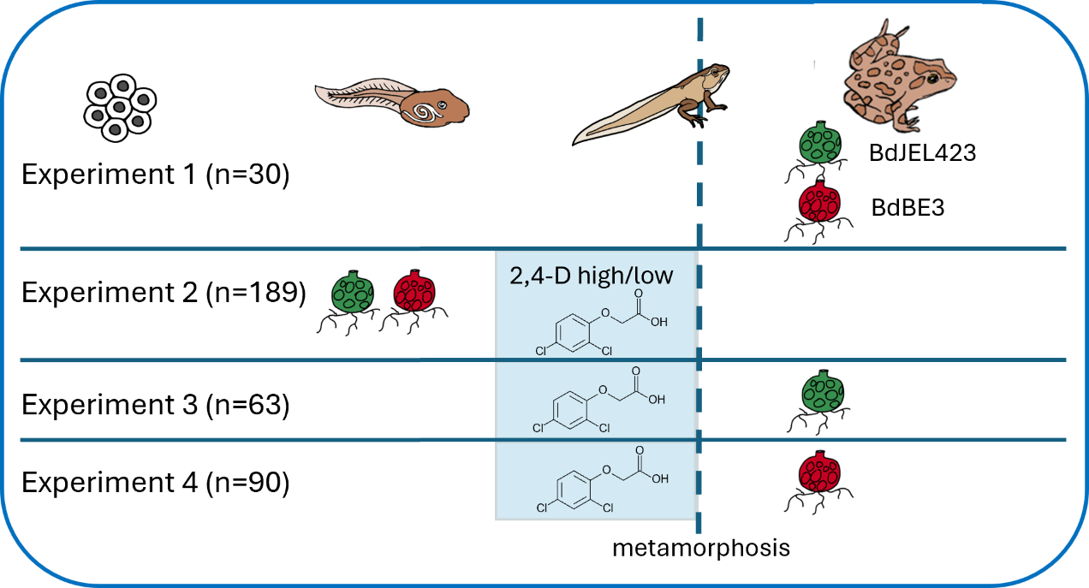
Figure 1: Graphical overview of the experiments.

2.1. Animals and housing
The animal experiments were performed following EU legislation and with the approval of the ethical committee of the Faculty of Veterinary Medicine (Ghent University EC2023/024). The experiments were carried out in a climate-controlled (~20 °C & ~80% relative humidity) room. Painted frog (D. pictus) tadpoles derived from a captive, Bd-free breeding colony and per experiment originated from the same clutch. Four experiments were conducted consecutively. The tadpoles were housed individually or in group (see experimental description below) in aquaria and were fed ad libitum fish pellets (Wafer mix, Tetra, Germany) and boiled endive. At metamorphosis the animals were transferred to individual plastic containers containing damp tissue and a hiding place (Javamoss, Taxiphyllum sp.). The animals were fed small crickets (Acheta domestica), aphids, fruit flies (Drosophila sp.) and springtails ad libitum.

2.2 Batrachochytrium dendrobatidis strains: culturing and detection
Two Bd strains were used in the experiments: BdBE3, an endemic strain isolated from an asymptomatic Alpine newt (Ichthyosaura alpestris) in Belgium and characterized as a low virulent strain for European amphibians, and BdJEL423, isolated from Agalychnis lemur considered a hypervirulent strain associated with community level declines in Panama and causing mortality in European anuran species (Greener et al., 2020). Cultures were maintained in TghL broth and spores were collected by flooding 4-day old cultures on TghL agar plates.

2.3 Infection trial readouts
We recorded Batrachochytrium dendrobatidis infection loads, clinical signs, length and weight of the animals. Infection loads were determined by using qPCR on skin swabs (in metamorphs), tadpole mouth parts (in tadpoles) or skin tissue (one complete metamorph’s leg) as described by Hyatt et al., 2007 with the respective isolate BdJEL423 or BdBE3 used as standard. Sample analysis was blinded. Clinical signs were assessed qualitatively by EBVS board certified veterinary specialists. For measuring length, metamorphs were photographed on mm paper and measured using ImageJ version 1.54d. Growth was determined as increase in snout vent length (SVL). Weight (mass, M) was determined to the nearest 0.01 g. For body condition, the scaled mass index (SMI) was calculated per timepoint as described by Peig and Green (2009): body mass × (SVL_{avg}/SVL)^{SMA}. The scaling component was estimated by the standardized major axis (SMA) regression of M on SVL, excluding all outliers. The change in body condition is calculated by subtracting the SMI at timepoint 2 from the SMI at timepoint 1. Clinical signs of chytridiomycosis were recorded and included lethargy, dysecdysis and death.

2.4 Exposure to 2,4-Dichlorophenoxyacetic acid (2,4-D)
2,4-D (Merck) was solved in water at concentrations 0.03 (= 2,4-D low) and 0.3 (= 2,4-D high) mg/l. During 5 consecutive days, tadpoles in the 2,4-D treatment groups were continuously bathed in daily prepared 2,4-D solutions. Animals from the control group were sham-bathed.

2.5 Experiment 1: comparing virulence of two Batrachochytrium dendrobatidis strains in frog metamorphs
In a first experiment, we compared the virulence of two BdGPL strains in painted frog metamorphs. Thirty painted frog metamorphs were divided into three groups: predicted low virulent BdBE3, highly virulent BdJEL423 and sham treated negative control. Each animal was housed alone. Four days post metamorphosis the animals were inoculated with 1 ml of 1.8 × 10⁶ BdBE3 or BdJEL423 spores in distilled water or distilled water (controls) for 24h at 20 °C. Before inoculation, the animals were weighed and photographed on mm paper. Twenty five days after Bd inoculation, the metamorphs were euthanized by an overdose of benzocaine, weighed, photographed on mm paper and the Bd infection load of the right leg was determined.

2.6 Experiment 2: effect of combined exposure of tadpoles to Batrachochytrium dendrobatidis and 2,4-D on infection, disease and growth until after metamorphosis
In a second experiment, we assessed the impact of exposure of tadpoles to a low or high concentration of 2,4-D after prior inoculation to a low or highly virulent Bd strain, until 16 days after metamorphosis. One hundred and eighty nine painted frog tadpoles were randomly divided into 9 treatment groups, with 21 tadpoles per group. Treatment consisted of the combination of sham inoculation or inoculation with the highly (BdJEL423) or the low (BdBE3) virulent Bd strain with exposure to different concentrations of 2,4-D (0, 0.03 and 0.3 mg/ml).
Tadpoles in the infected groups were inoculated at 14 days of age to one of the respective Bd strains. For this inoculation the tadpoles were group housed per Bd strain and inoculated with BdJEL423 or BdBE3 in 500 ml water containing 5.8 × 10⁵ spores/ml water. The tadpoles from the non-infected groups, received a sham treatment. After 24h exposure at 20°C, the tadpoles were housed individually and allocated to their respective treatment group. At 23 days of age, the tadpoles were housed in groups of 5 or 6 tadpoles (4 groups per treatment). To assess infection success, at 23 days of age, an additional 12 sentinel tadpoles per Bd strain were euthanized by an overdose of benzocaine, their mouthparts were collected and the Bd load was determined. At the age of 28 days (nearing metamorphosis), the group-housed tadpoles were exposed to a concentration of 2,4-D (0, 0.03 and 0.3 mg/ml) for 5 days. At metamorphosis, the metamorphs were photographed on mm paper and housed individually. Sixteen days after metamorphosis (at an age of 49 days) the tadpoles were euthanized by an overdose of benzocaine, weighed, photographed on mm paper and the Bd infection load of the right leg was determined (Greener et al., 2020).

2.7 Experiment 3: effect of tadpole exposure to a low or high dose of 2,4-D on subsequent infection of their metamorph stage with Batrachochytrium dendrobatidis BdJEL423
Here, we quantified the effect of exposure to two concentrations of 2,4-D during the tadpole stage on a highly virulent (BdJEL423) Bd infection in painted frog metamorphs.
Sixty-three painted frog tadpoles were divided into three treatment groups: 2,4-D low, 2,4-D high and control. Shortly before the onset of metamorphosis at an age of 28 days, the animals were exposed to 0, 0.03 or 0.3 mg/l 2,4-D. The animals were housed in groups of 5 or 6 tadpoles. From metamorphosis onwards the animals were housed individually. Sixteen days post metamorphosis, 11 animals per group were inoculated with 1 ml of 1.8 × 10⁶ of BdJEL423 spores or distilled water for 24h at 20 °C. Before inoculation, the animals were weighed and photographed on mm paper. Ten days after Bd inoculation, the tadpoles were euthanized by an overdose of benzocaine, weighed, photographed on mm paper and the Bd infection load of the right leg was determined.

2.8 Experiment 4: effect of tadpole exposure to a low or high dose of 2,4-D on subsequent infection of their metamorph stage with Batrachochytrium dendrobatidis BdBE3
Here, we quantified the effect of exposure to two concentrations of 2,4-D during the tadpole stage on a low virulent (BdBE3) Bd infection in painted frog metamorphs.
Ninety painted frog tadpoles were divided into three groups: 2,4-D low, 2,4-D high and control. Shortly before the onset of metamorphosis at an age of 20 days, the animals were exposed to 0, 0.03 or 0.3 mg/l 2,4-D for five days. The animals were treated in groups of 6 animals. At metamorphosis, all froglets were housed individually. Four days post metamorphosis 15 animals per 2,4-D treatment were inoculated with 1 ml of 1.8 × 10⁶ of BdBE3 spores or distilled water for 24h at 20 °C. Before inoculation, the animals were weighed and photographed on mm paper. Ten days after Bd inoculation, the tadpoles were euthanized by an overdose of benzocaine, weighed, photographed on mm paper and the Bd infection load of the right leg was determined.

  - Statistics
All statistical analysis were performed in R (v4.3.2) (R Core Team, 2023) and figures were made using ggplot2 (Wickham, 2016), a collection of R-packages, and ggpubr (Kassambara, 2023). We considered a test statistically significant when the p-value is below the significance level of 0.05.
We first assessed the virulence of different strains across various stages of development. The data from experiment 2 was used to investigate the virulence of strains when tadpoles were inoculated, while the data of experiment 1 focused on the effects when metamorphs were inoculated. We performed several analysis of variances (ANOVAs) to determine differences between groups, whereby we modelled the variable of interest (Bd load, days to metamorphosis, growth or SMI) as the response variable and the treatment (inoculation with Bd strains) as the predictor variable. For the tests involving tadpoles inoculated with Bd (experiment 2), we also included the different 2,4-D treatments as an additional predictor variable. We restricted the dataset to infected groups when we assessed the difference in Bd loads. When the ANOVA test was significant, we performed post-hoc Tukey tests to check which groups differed. The assumptions of normality and homoscedasticity were assessed with a Shapiro test and a Levene’s test from the car package (Fox and Weisberg, 2019).When assumptions were not met, we used Kruskal-Wallis as a non-parametric alternative. For post-hoc comparisons in such cases, pairwise Wilcoxon tests with false discovery rate (fdr) correction for multiple comparisons were applied.
Next, we investigated the effects of 2,4-D. Similar approaches were used, using ANOVA when the assumptions were met and the non-parametric Kruskal-Wallis otherwise. The response variable included days to metamorphosis, length at metamorphosis, metamorph growth or SMI gain, while 2,4-D and Bd treatments were the predictor variables. To analyse the effect of 2,4-D on tadpole growth, we combined the data from experiments 2,3 and 4, and incorporated an experiment effect in the model. All other tests were based on data from only experiments 2 and 3.
Finally, we evaluated the combined effects of Bd and 2,4-D. To assess the impact of 2,4-D on Bd loads, we used data from experiment 2, restricted to animals that were inoculated prior to 2,4-D exposure. Given the excess of zeros in the GE load counts we applied a zero-inflated negative binomial mixed model using the glmmTMB package (Brooks et al., 2017). In this model, Bd load was the response variable, while Bd strain and 2,4-D treatment, as continuous variable, were the fixed effects, and grouping was included as a random effect. The effects of 2,4-D on the growth, weight gain or SMI gain of metamorphs exposed to different strains were tested with ANOVAs, using the data from experiments 3 or 4, in which tadpoles were exposed to 2,4-D prior to infection of metamorphs. Growth or SMI gain were the response variables, and Bd strain, 2,4-D and their interaction were included as predictor variables. The method is similar as before, where we first tested assumptions. When the assumptions are not fulfilled we performed the non-parametric alternative.

3. Results

A summary of the data and all raw data are presented in Supplementary Table 1.

3.1 Inoculation of tadpoles with low-virulent Bd expedites metamorphosis and promotes post metamorph infection, while inoculation of tadpoles with highly virulent Bd impairs post metamorph growth
Inoculation of painted frog tadpoles with Bd resulted in infection of 8 out of 12 tadpoles exposed to the (predicted) highly virulent BdJEL423 strain and 5 out of 12 for the (predicted) less virulent BdBE3 strain at nine days post-inoculation. Fungal loads were significantly higher in tadpoles inoculated with BdJEL423 (mean GE ± SD: 417 ± 617) than in those inoculated with BdBE3 (51 ± 123; χ²(1) = 4.31, p = 0.038, Figure 2A). However, by 35 days post-inoculation (equivalent to 16 days post-metamorphosis) all animals had cleared the infection (Bd load = 0).
Time to metamorphosis differed significantly by Bd strain (χ²(2) = 8.37, p = 0.015): tadpoles inoculated with BdBE3 began metamorphosis one day earlier on average than uninfected controls (p = 0.016).
No signs of disease (e.g., lethargy, dysecdysis, or mortality) were observed after metamorphosis but growth was significantly impaired in BdJEL423-inoculated animals by day 35 (F(2, 184) = 7.49, p < 0.001, Figure 2B). These individuals grew, on average, 0.55 mm less than uninfected frogs (p < 0.001) and 0.36 mm less than those inoculated with BdBE3 (p = 0.039).

3.2 Infection of metamorphs with low or highly virulent Bd impairs growth, but only highly virulent Bd reduces body condition
At 25 days post-inoculation, inoculation to Bd after metamorphosis resulted in significantly higher BdBE3 loads (mean GE ± SD, 8953 ± 16 304) than BdJEL 423 (209 ± 228; χ²(1) = 12.62, p < 0.001, Figure 2D). Growth was reduced in all Bd inoculated metamorphs compared to uninfected froglets (χ²(2) = 14.98, p < 0.001, Figure 2E). Both BdBE3 (p = 0.0017) and BdJEL423 (p = 0.045) had significantly lower growth compared to uninfected individuals, but BdJEL423 inoculated individuals grew more than those inoculated with BdBE3 (p = 0.015).
Also the SMI 25 days post-inoculation is different between groups (F(2, 27) = 4.50, p-value = 0.021, Figure 2F), but is only impacted by inoculation to BdJEL423, the highly virulent strain, compared to the uninfected animals (p = 0.015). All results reported are based on data from experiment 1.

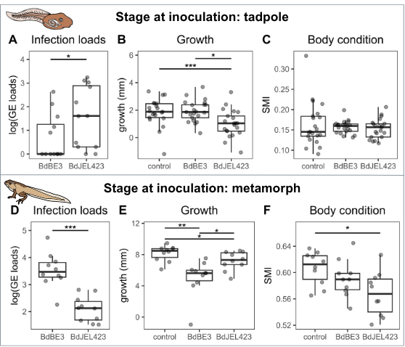

Figure 2: Boxplots showing the effects of Bd inoculation at different life stages of painted frogs (D. pictus) on infection loads, growth and body condition. The data shown here are only animals that are not exposed to 2,4-D from experiment 2 (tadpole) and 1 (metamorph). A) Infection loads (log-transformed genomic equivalents, GE) taken in the mouthparts of the tadpoles on day 9 post-inoculation. B) Growth (in mm), from day of metamorphosis to 16 days post-metamorphosis for the individuals exposed as tadpoles. C) SMI as a metric for body condition on day 16 post-metamorphosis (equivalent to 35 days post-inoculation). D) Infection loads (log-transformed genomic equivalents, GE) taken in the right leg of the metamorphs, 35 days post-inoculation. E) When exposed as metamorph, growth from day of inoculation to 25 post-inoculation. F) SMI as a metric for body condition on day 25 post-inoculation (metamorph).

3.3 Five days exposure of tadpoles to 0.3 mg/l of 2,4-D results in impaired growth persisting after metamorphosis
Exposure of tadpoles to either 0.03 or 0.3 mg/l of 2,4-D had no impact on survival or morphology of the tadpoles. In experiment 2, no effect on time to metamorphosis was noticed (χ²(2) = 4.10, p > 0.05), which was on average 35.29 days.
However, the length at metamorphose was impacted by 2,4-D (F(2, 275) = 8.51, p < 0.001). Tadpoles exposed to the higher 2,4-D concentration (0.3 mg/l) were, on average, 4.2% smaller at metamorphosis compared to uninfected animals (p < 0.001), based on the data from experiments 2, 3 and 4 together.
No compensatory growth was observed post-metamorphosis until day 14 (experiment 4, F(2,84) = 2.21, p > 0.05, Figure 3B) or 16 post-metamorphosis (experiments 2 and 3; F(2, 180) = 0.73, p > 0.05).
Body condition (SMI) was not affected by 2,4-D concentration on both 16 days (χ²(2) = 0.48, p > 0.05, experiments 2 and 3) and 14 days post-metamorphosis (χ²(2) = 2.55, p > 0.05, experiment 4).

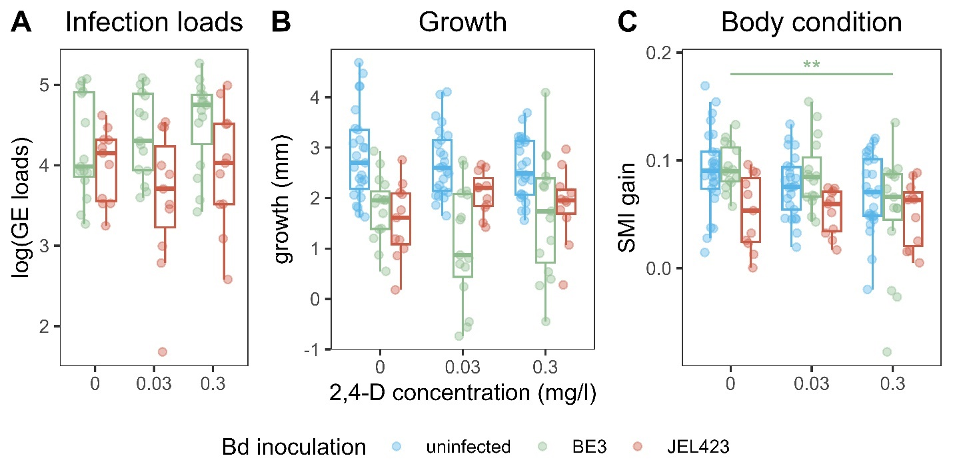
Figure 3: Boxplots illustrating the effects of different 2,4-D concentrations (0.03 mg/l, 0.3 mg/l) and Bd inoculation on infection loads, growth and body condition in metamorphosed painted frogs (D. pictus). The colors represent the different Bd treatment groups: uninfected (blue), BdBE3 (green) and BdJEL423 (red). The data included are from experiments 3 and 4. A) Infection loads (log-transformed genomic equivalents, GE) on Day 10 after inoculation B) Growth (in mm), from day of inoculation to 10 days post-inoculation C) The difference in Scaled Mass Index (SMIgain) between day of inoculation and 10 days post-metamorphosis, as a metric for impact on body condition.

3.4 Co-exposure of tadpoles to 2,4-D and low virulent BdBE3 increases infection load and decreases body condition
When tadpoles were first inoculated with Bd and subsequently exposed to 2,4-D (continuous predictor), they were more likely to be infected with BdBE3 (but not JEL423) after metamorphosis (experiment 2, β_{zi} = 2.61, SE = 1.14, p = 0.023). Once infected, five-day exposure of tadpoles to 2,4-D resulted in higher BdBE3 infection loads in metamorphs (β_{c} = 0.056, SE = 0.024, p = 0.022). Although exposure to 0.3 mg/l 2,4-D reduced length at metamorphosis, it did not affect post metamorph growth until 14 days post-metamorphosis in BdBE3-inoculated (χ²(2) = 1.03, p > 0.05, experiment 4) or 26 days post-metamorphosis in BdJEL423-inoculated animals (F(2, 59) = 1.40, p > 0.05, experiment 3). SMI gain was only affected by 2,4-D in combination with BdBE3-inoculation (χ²(2) = 6.27, p = 0.044, experiment 4), and not with BdJEL423 (F(2, 57) = 1.09, p > 0.05, experiment 3). To conclude, exposure to 2,4-D results in smaller metamorphs. Co-exposure of 2,4-D with BdBE3 but not JEL423 results in a higher prevalence and higher infection loads and reduced body condition.

4. Discussion

We demonstrate pronounced effects on anuran development of widespread fungal pathogens (BdGPL) and a commonly used herbicide. The impact of BdGPL alone markedly depended on the fungal strain. Infection of European frogs with a European isolate of BdGPL was consistent with characteristics of pathogen endemism that promote fungal persistence at a limited cost for the infected host. While infection burden reached high levels in infected metamorphs, the cost for the host was limited to growth reduction. This negative impact was observed only if inoculation with Bd occurred after metamorphosis but not tadpole stage. In contrast, infection with the exotic BdGPL isolate, both at the tadpole and metamorph stage, resulted in lower infection burden, but markedly stunted, nearly halted growth and reduced body condition. While translating such results to the field situation should be done with care, these results align with the hypothesis that at least a proportion of European BdGPL strains behave as endemic, low impact parasites, adapted to persist in amphibian populations (Greener et al., 2020). In contrast, exotic strains may be less adapted but may exert a larger impact. Strain dependent epidemiological scenarios may explain reported differences in disease course: while Bd positive Discoglossus sp. populations have been described in the absence of mortality events (El Mouden et al., 2011; Montori et al., 2019), others have experienced mortality events (Bielby et al., 2009; Martínez-Silvestre et al., 2023). Further studies to understand the differential impact of strains within the GPL clade within an ecosystem are warranted to direct preventive and mitigative actions.

Exposure of painted frog tadpoles to 2,4-D during 5 days impaired larval growth, which was not compensated after metamorphosis. Such sublethal effects can have significant impacts on the fitness of individual frogs, their populations, and the broader ecosystems they inhabit. For amphibians, body size at metamorphosis is closely associated with survival and reproductive success of subsequent life stages (Berven and Gill, 1983; Gray and Smith, 2005; Semlitsch et al., 1988). Individuals with large body size at metamorphosis have higher survival, greater future reproductive success than small-bodied individuals and increased resistance to dehydration (Berven and Gill, 1983; Semlitsch et al., 1988; Spight, 1968; Tracy et al., 2010). Therefore, Lopes and Ortiz-Santaliestra (2023) recommended that body mass at metamorphosis completion and time to metamorphosis should be monitored in parallel to other endpoints that are conventionally measured at stage NF62 in order to evaluate pesticide toxicity.

Buck et al., 2015 described that exposure to pesticides may alter dynamics of Bd and amphibian hosts in subtle and complex ways. Here, a marked, negative effect of co-exposure to the herbicide 2,4-D and Bd was noticed, be it largely limited to infections with the low virulent Bd isolate. When inoculated during the tadpole stage, 2,4-D exposure increased infection loads post metamorphosis. When inoculated during the metamorph stage, prior 2,4-D exposure during the tadpole stage impaired metamorph body condition. 2,4-D thus brought the virulence of the endemic, low virulent strain on par with that of the highly virulent JEL423. An increased cost for the infected host, combined with increased pathogen shedding may result in altered infection and disease dynamics in the field. Interestingly, no such effect was noticed after exposure to the highly virulent Bd strain. We attribute this to the already pronounced impact of the latter on metamorph growth, the almost zero growth not allowing for much exacerbation. The finding that pesticides may alter infection dynamics and cost of infection to hosts, stresses the importance of considering the environmental context in chytridiomycosis epidemiology.

In a context of global distribution of amphibian pathogens, widespread use of agrochemicals and the current amphibian crisis, we recommend to include pesticide use policy in programs, targeted at conserving amphibians that are vulnerable to disease induced declines.

CRediT authorship contribution statement
An Martel: Conceptualization, Methodology, Investigation, Formal analysis, Writing – original draft, Writing – review & editing, Resources
Ellen Blomme: Formal analysis, Writing – original draft, Writing – review & editing
Elin Verbrugghe: Formal analysis, Writing – review & editing
Sofie Debruyckere: Methodology, Writing – review & editing
Manuel E. Ortiz-: Conceptualization, Writing – review & editing, Resources
Jean-Louis Dorne: Writing – review & editing, Resources
Frank Pasmans: Conceptualization, Formal analysis, Writing – original draft, Writing – review & editing, Resources

Declaration of competing interest
The authors declare that they have no known competing financial interests or personal relationships that could have appeared to influence the work reported in this paper.

Acknowledgements
This study is part of the project “AMPHIDEB: Development of biologically-based models in environmental risk assessment to assess the impact of chemicals and pathogenic fungi on amphibian and reptile populations” funded by EFSA (European Food Safety Authority).

Appendix A. Supplementary data

Data availibility

References
Baker, N.J., Bancroft, B.A., Garcia, T.S., 2013. A meta-analysis of the effects of pesticides and fertilizers on survival and growth of amphibians. Science of The Total Environment 449, 150–156. https://doi.org/10.1016/j.scitotenv.2013.01.056
Barbi, A., Goessens, T., Strubbe, D., Deknock, A., Van Leeuwenberg, R., De Troyer, N., Verbrugghe, E., Greener, M., De Baere, S., Lens, L., Goethals, P., Martel, A., Croubels, S., Pasmans, F., 2023. Widespread triazole pesticide use affects infection dynamics of a global amphibian pathogen. Ecol Lett 26, 313–322. https://doi.org/10.1111/ele.14154
Berven, K.A., Gill, D.E., 1983. Interpreting Geographic Variation in Life-History Traits. American Zoologist 23, 85–97. https://doi.org/10.1093/icb/23.1.85
Bielby, J., Bovero, S., Sotgiu, G., Tessa, G., Favelli, M., Angelini, C., Doglio, S., Clare, F.C., Gazzaniga, E., Lapietra, F., Garner, T.W.J., 2009. Fatal Chytridiomycosis in the Tyrrhenian Painted Frog. EcoHealth 6, 27–32. https://doi.org/10.1007/s10393-009-0232-2
Bosch, J., Martínez-Solano, I., 2006. Chytrid fungus infection related to unusual mortalities of Salamandra salamandra and Bufo bufo in the Peñalara Natural Park, Spain. Oryx 40, 84–89. https://doi.org/10.1017/S0030605306000093
Bosch, J., Martı́nez-Solano, I., Garcı́a-Parı́s, M., 2001. Evidence of a chytrid fungus infection involved in the decline of the common midwife toad (Alytes obstetricans) in protected areas of central Spain. Biological Conservation 97, 331–337. https://doi.org/10.1016/S0006-3207(00)00132-4
Brovini, E.M., de Deus, B.C.T., Vilas-Boas, J.A., Quadra, G.R., Carvalho, L., Mendonça, R.F., Pereira, R. de O., Cardoso, S.J., 2021. Three-bestseller pesticides in Brazil: Freshwater concentrations and potential environmental risks. Science of The Total Environment 771, 144754. https://doi.org/10.1016/j.scitotenv.2020.144754
Buck, J.C., Hua, J., Brogan III, W.R., Dang, T.D., Urbina, J., Bendis, R.J., Stoler, A.B., Blaustein, A.R., Relyea, R.A., 2015. Effects of Pesticide Mixtures on Host-Pathogen Dynamics of the Amphibian Chytrid Fungus. PLoS ONE 10. https://doi.org/10.1371/journal.pone.0132832.
Carvalho, F.P., 2017. Pesticides, environment, and food safety. Food and Energy Security 6, 48–60. https://doi.org/10.1002/fes3.108
Chew, A., West, M., Berger, L., Brannelly, L.A., 2024. The impacts of water quality on the amphibian chytrid fungal pathogen: A systematic review. Environ Microbiol Rep 16, e13274. https://doi.org/10.1111/1758-2229.13274
Chingombe, P., Saha, B., Wakeman, R.J., 2006. Effect of surface modification of an engineered activated carbon on the sorption of 2,4-dichlorophenoxy acetic acid and benazolin from water. Journal of Colloid and Interface Science 297, 434–442. https://doi.org/10.1016/j.jcis.2005.10.054
Clare, F.C., Halder, J.B., Daniel, O., Bielby, J., Semenov, M.A., Jombart, T., Loyau, A., Schmeller, D.S., Cunningham, A.A., Rowcliffe, M., Garner, T.W.J., Bosch, J., Fisher, M.C., 2016. Climate forcing of an emerging pathogenic fungus across a montane multi-host community. Philosophical Transactions of the Royal Society B: Biological Sciences 371, 20150454. https://doi.org/10.1098/rstb.2015.0454
El Mouden, E.H., Slimani, T., Donaire-Barroso, D., Fernández-Beaskoetxea, S., Fisher, M.C., Bosch, J., 2011. First Record of the Chytrid Fungus Batrachochytrium dendrobatidis in North Africa. Herpetol Rev 42, 71–75.
Fox, J., Weisberg, S., 2019. An R Companion to Applied Regression, third. ed. Sage, Thousand Oaks CA.
Freitas, J.S., Girotto, L., Goulart, B.V., Alho, L. de O.G., Gebara, R.C., Montagner, C.C., Schiesari, L., Espíndola, E.L.G., 2019. Effects of 2,4-D-based herbicide (DMA® 806) on sensitivity, respiration rates, energy reserves and behavior of tadpoles. Ecotoxicology and Environmental Safety 182, 109446. https://doi.org/10.1016/j.ecoenv.2019.109446
Gaietto, K.M., Rumschlag, S.L., Boone, M.D., 2014. Effects of pesticide exposure and the amphibian chytrid fungus on gray treefrog (Hyla chrysoscelis) metamorphosis. Environmental Toxicology and Chemistry 33, 2358–2362. https://doi.org/10.1002/etc.2689
Gray, M.J., Smith, L.M., 2005. Influence of land use on postmetamorphic body size of Playa lake amphibians. wild 69, 515–524. https://doi.org/10.2193/0022-541X(2005)069[0515:IOLUOP]2.0.CO;2
Greener, M.S., Verbrugghe, E., Kelly, M., Blooi, M., Beukema, W., Canessa, S., Carranza, S., Croubels, S., De Troyer, N., Fernandez-Giberteau, D., Goethals, P., Lens, L., Li, Z., Stegen, G., Strubbe, D., van Leeuwenberg, R., Van Praet, S., Vila-Escale, M., Vervaeke, M., Pasmans, F., Martel, A., 2020. Presence of low virulence chytrid fungi could protect European amphibians from more deadly strains. Nat Commun 11, 5393. https://doi.org/10.1038/s41467-020-19241-7
Hyatt, A.D., Boyle, D.G., Olsen, V., Boyle, D.B., Berger, L., Obendorf, D., Dalton, A., Kriger, K., Hero, M., Hines, H., Phillott, R., Campbell, R., Marantelli, G., Gleason, F., Colling, A., 2007. Diagnostic assays and sampling protocols for the detection of Batrachochytrium dendrobatidis. Diseases of Aquatic Organisms 73, 175–192. https://doi.org/10.3354/dao073175
Kassambara, A., 2023. ggpubr: “ggplot2” Based Publication Ready Plots.
Le, T.D.H., Pham, L.H., Dinh, Q.T., Le, T.M.T., Tram, N.T.B., 2023. Land Use Influencing the Distribution of Pesticides in Surface Water: The Case of the Ma River and Its Tributaries in Thanh Hoa Province, Vietnam. Arch Environ Contam Toxicol 85, 290–301. https://doi.org/10.1007/s00244-023-01018-w
Lopes, I., Ortiz-Santaliestra, M., 2023. Assessment of exposure routes of aphibians and reptiles to pesticides and extrapolation of pesticide toxicity from suborganismal level to apical effects.
Luedtke, J.A., Chanson, J., Neam, K., Hobin, L., Maciel, A.O., Catenazzi, A., Borzée, A., Hamidy, A., Aowphol, A., Jean, A., Sosa-Bartuano, Á., Fong G., A., de Silva, A., Fouquet, A., Angulo, A., Kidov, A.A., Muñoz Saravia, A., Diesmos, A.C., Tominaga, A., Shrestha, B., Gratwicke, B., Tjaturadi, B., Martínez Rivera, C.C., Vásquez Almazán, C.R., Señaris, C., Chandramouli, S.R., Strüssmann, C., Cortez Fernández, C.F., Azat, C., Hoskin, C.J., Hilton-Taylor, C., Whyte, D.L., Gower, D.J., Olson, D.H., Cisneros-Heredia, D.F., Santana, D.J., Nagombi, E., Najafi-Majd, E., Quah, E.S.H., Bolaños, F., Xie, F., Brusquetti, F., Álvarez, F.S., Andreone, F., Glaw, F., Castañeda, F.E., Kraus, F., Parra-Olea, G., Chaves, G., Medina-Rangel, G.F., González-Durán, G., Ortega-Andrade, H.M., Machado, I.F., Das, I., Dias, I.R., Urbina-Cardona, J.N., Crnobrnja-Isailović, J., Yang, J.-H., Jianping, J., Wangyal, J.T., Rowley, J.J.L., Measey, J., Vasudevan, K., Chan, K.O., Gururaja, K.V., Ovaska, K., Warr, L.C., Canseco-Márquez, L., Toledo, L.F., Díaz, L.M., Khan, M.M.H., Meegaskumbura, M., Acevedo, M.E., Napoli, M.F., Ponce, M.A., Vaira, M., Lampo, M., Yánez-Muñoz, M.H., Scherz, M.D., Rödel, M.-O., Matsui, M., Fildor, M., Kusrini, M.D., Ahmed, M.F., Rais, M., Kouamé, N.G., García, N., Gonwouo, N.L., Burrowes, P.A., Imbun, P.Y., Wagner, P., Kok, P.J.R., Joglar, R.L., Auguste, R.J., Brandão, R.A., Ibáñez, R., von May, R., Hedges, S.B., Biju, S.D., Ganesh, S.R., Wren, S., Das, S., Flechas, S.V., Ashpole, S.L., Robleto-Hernández, S.J., Loader, S.P., Incháustegui, S.J., Garg, S., Phimmachak, S., Richards, S.J., Slimani, T., Osborne-Naikatini, T., Abreu-Jardim, T.P.F., Condez, T.H., De Carvalho, T.R., Cutajar, T.P., Pierson, T.W., Nguyen, T.Q., Kaya, U., Yuan, Z., Long, B., Langhammer, P., Stuart, S.N., 2023. Ongoing declines for the world’s amphibians in the face of emerging threats. Nature 622, 308–314. https://doi.org/10.1038/s41586-023-06578-4
Maggi, F., Tang, F.H.M., la Cecilia, D., McBratney, A., 2019. PEST-CHEMGRIDS, global gridded maps of the top 20 crop-specific pesticide application rates from 2015 to 2025. Sci Data 6, 170. https://doi.org/10.1038/s41597-019-0169-4
Martínez-Silvestre, A., Loras-Ortí, F., Garcia-Salmeron, A., Pujol-Buxó, E., Pérez-Novo, I., Maluquer-Margalef, J., Poch, S., Thumsová, B., Bosch, J., 2023. Introduced Mediterranean painted frogs (Discoglossus pictus) are possible supershedders of the fungus Batrachochytrium dendrobatidis in Catalonia (NE Spain). Amphibia-Reptilia 44, 257–261. https://doi.org/10.1163/15685381-bja10133
McMahon, T.A., Romansic, J.M., Rohr, J.R., 2013. Nonmonotonic and Monotonic Effects of Pesticides on the Pathogenic Fungus Batrachochytrium dendrobatidis in Culture and on Tadpoles. Environ. Sci. Technol. 47, 7958–7964. https://doi.org/10.1021/es401725s
Mirzaei, R., Yunesian, M., Nasseri, S., Gholami, M., Jalilzadeh, E., Shoeibi, S., Bidshahi, H.S., Mesdaghinia, A., 2017. An optimized SPE-LC-MS/MS method for antibiotics residue analysis in ground, surface and treated water samples by response surface methodology- central composite design. J Environ Health Sci Eng 15, 21. https://doi.org/10.1186/s40201-017-0282-2
Montori, A., Sebastián, O.S., Franch, M., Pujol-Buxó, E., Llorente, G.A., Fernández-Loras, A., Richter-Boix, À., Bosch, J., 2019. Observations on the intensity and prevalence of Batrachochytridium dendrobatidis in sympatric and allopatric Epidalea calamita (native) and Discoglossus pictus (invasive) populations. Basic and Applied Herpetology 33, 5–17. https://doi.org/10.11160/bah.137
Peig, J., Green, A.J., 2009. New perspectives for estimating body condition from mass/length data: the scaled mass index as an alternative method. Oikos 118, 1883–1891. https://doi.org/10.1111/j.1600-0706.2009.17643.x
R Core Team, 2023. R: A Language and Environment for Statistical Computing.
Santos, G.D., Rutkoski, C.F., Folador, A., Skovronski, V.J., Müller, C., Pompermaier, A., Hartmann, P.A., Hartmann, M., 2024. 2,4-D-based herbicide underdoses cause mortality, malformations, and nuclear abnormalities in Physalaemus cuvieri tadpoles. Comp Biochem Physiol C Toxicol Pharmacol 277, 109840. https://doi.org/10.1016/j.cbpc.2024.109840
Scheele, B.C., Pasmans, F., Skerratt, L.F., Berger, L., Martel, A., Beukema, W., Acevedo, A.A., Burrowes, P.A., Carvalho, T., Catenazzi, A., De la Riva, I., Fisher, M.C., Flechas, S.V., Foster, C.N., Frías-Álvarez, P., Garner, T.W.J., Gratwicke, B., Guayasamin, J.M., Hirschfeld, M., Kolby, J.E., Kosch, T.A., La Marca, E., Lindenmayer, D.B., Lips, K.R., Longo, A.V., Maneyro, R., McDonald, C.A., Mendelson, J., Palacios-Rodriguez, P., Parra-Olea, G., Richards-Zawacki, C.L., Rödel, M.-O., Rovito, S.M., Soto-Azat, C., Toledo, L.F., Voyles, J., Weldon, C., Whitfield, S.M., Wilkinson, M., Zamudio, K.R., Canessa, S., 2019. Amphibian fungal panzootic causes catastrophic and ongoing loss of biodiversity. Science 363, 1459–1463. https://doi.org/10.1126/science.aav0379
Semlitsch, R.D., Scott, D.E., Pechmann, J.H.K., 1988. Time and Size at Metamorphosis Related to Adult Fitness in Ambystoma Talpoideum. Ecology 69, 184–192. https://doi.org/10.2307/1943173
Song, Y., 2014. Insight into the mode of action of 2,4-dichlorophenoxyacetic acid (2,4-D) as an herbicide. J Integr Plant Biol 56, 106–113. https://doi.org/10.1111/jipb.12131
Spight, T.M., 1968. The Water Economy of Salamanders: Evaporative Water Loss. Physiological Zoology 41, 195–203. https://doi.org/10.1086/physzool.41.2.30155450
Tracy, Christopher R., Christian, K.A., Tracy, C. Richard, 2010. Not just small, wet, and cold: effects of body size and skin resistance on thermoregulation and arboreality of frogs. Ecology 91, 1477–1484. https://doi.org/10.1890/09-0839.1
Trapp, M., Deubert, M., Streib, L., Scholz-Starke, B., Roß-Nickoll, M., Toschki, A., 2020. Simulating the Effects of Agrochemicals and Other Risk-Bearing Management Measures on the Terrestrial Agrobiodiversity: The RISKMIN Approach, in: Mirschel, W., Terleev, V.V., Wenkel, K.-O. (Eds.), Landscape Modelling and Decision Support. Springer International Publishing, Cham, pp. 443–459. https://doi.org/10.1007/978-3-030-37421-1_23
Vanryckeghem, F., Huysman, S., Van Langenhove, H., Vanhaecke, L., Demeestere, K., 2019. Multi-residue quantification and screening of emerging organic micropollutants in the Belgian Part of the North Sea by use of Speedisk extraction and Q-Orbitrap HRMS. Marine Pollution Bulletin 142, 350–360. https://doi.org/10.1016/j.marpolbul.2019.03.049
Wickham, H., 2016. ggplot2: Elegant Graphics for Data Analysis., Use R! Springer International Publishing, Cham. https://doi.org/10.1007/978-3-319-24277-4
Wise, R.S., Rumschlag, S.L., Boone, M.D., 2014. Effects of amphibian chytrid fungus exposure on American toads in the presence of an insecticide. Environ Toxicol Chem 33, 2541–2544. https://doi.org/10.1002/etc.2709
Yorlano, M.F., Demetrio, P.M., Rimoldi, F., 2022. Riparian strips as attenuation zones for the toxicity of pesticides in agricultural surface runoff: Relative influence of herbaceous vegetation and terrain slope on toxicity attenuation of 2,4-D. Science of The Total Environment 807, 150655. https://doi.org/10.1016/j.scitotenv.2021.150655

